**ShopBridge API**

1. Uploaded a file “ShopBridge_SQLQueries.sql” to GitHub with SQL queries to create below tables. Run the queries in the file before running the code. **(Time: 10 min)**
   1. Create table “Product.ProductCategory”

|  |  |
| --- | --- |
| **Column Name** | **DataType** |
| iProductCategoryID | Int PK |
| vchProductCategoryName | Varchar(50) |

* 1. Create table “Product.Products”

|  |  |
| --- | --- |
| **Column Name** | **DataType** |
| iProductID | Int PK |
| vchProductName | Varchar(50) |
| vchDescription | Varchar(100) |
| dPrice | decimal |
| bIsAvailable | bit |
| iProductCategoryID | Int FK |
| vchBrand | Varchar(20) |

1. After the tables are created, update the connection string in the web.config file in “ShopBridge.Api” project with the respective values.
2. Used Entity Framework to connect to the Database.
3. Below are the API details.
   1. **api/Products**: This is a GET method to return the list of all products in the inventory.

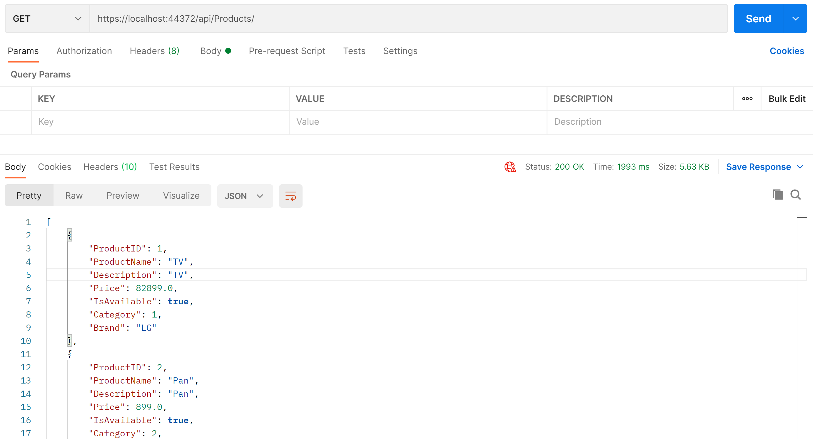

* 1. **api/Products/{id}**: This is a GET method to return the details of a single product based on ProductID.

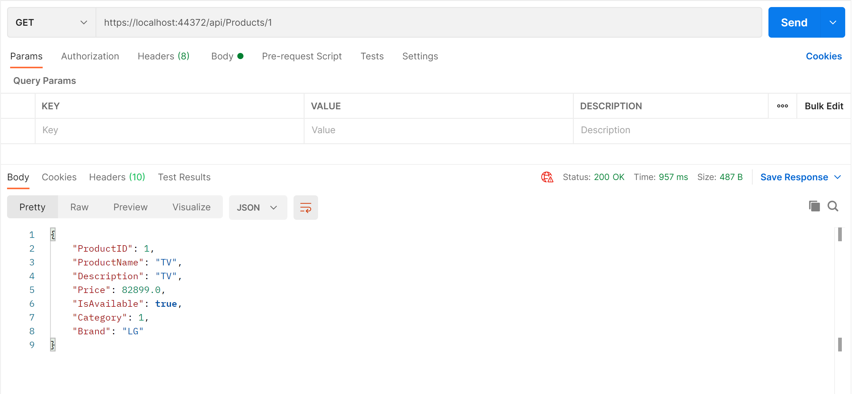

* 1. **api/Products/Add**: This is a POST method to add a product to the inventory.

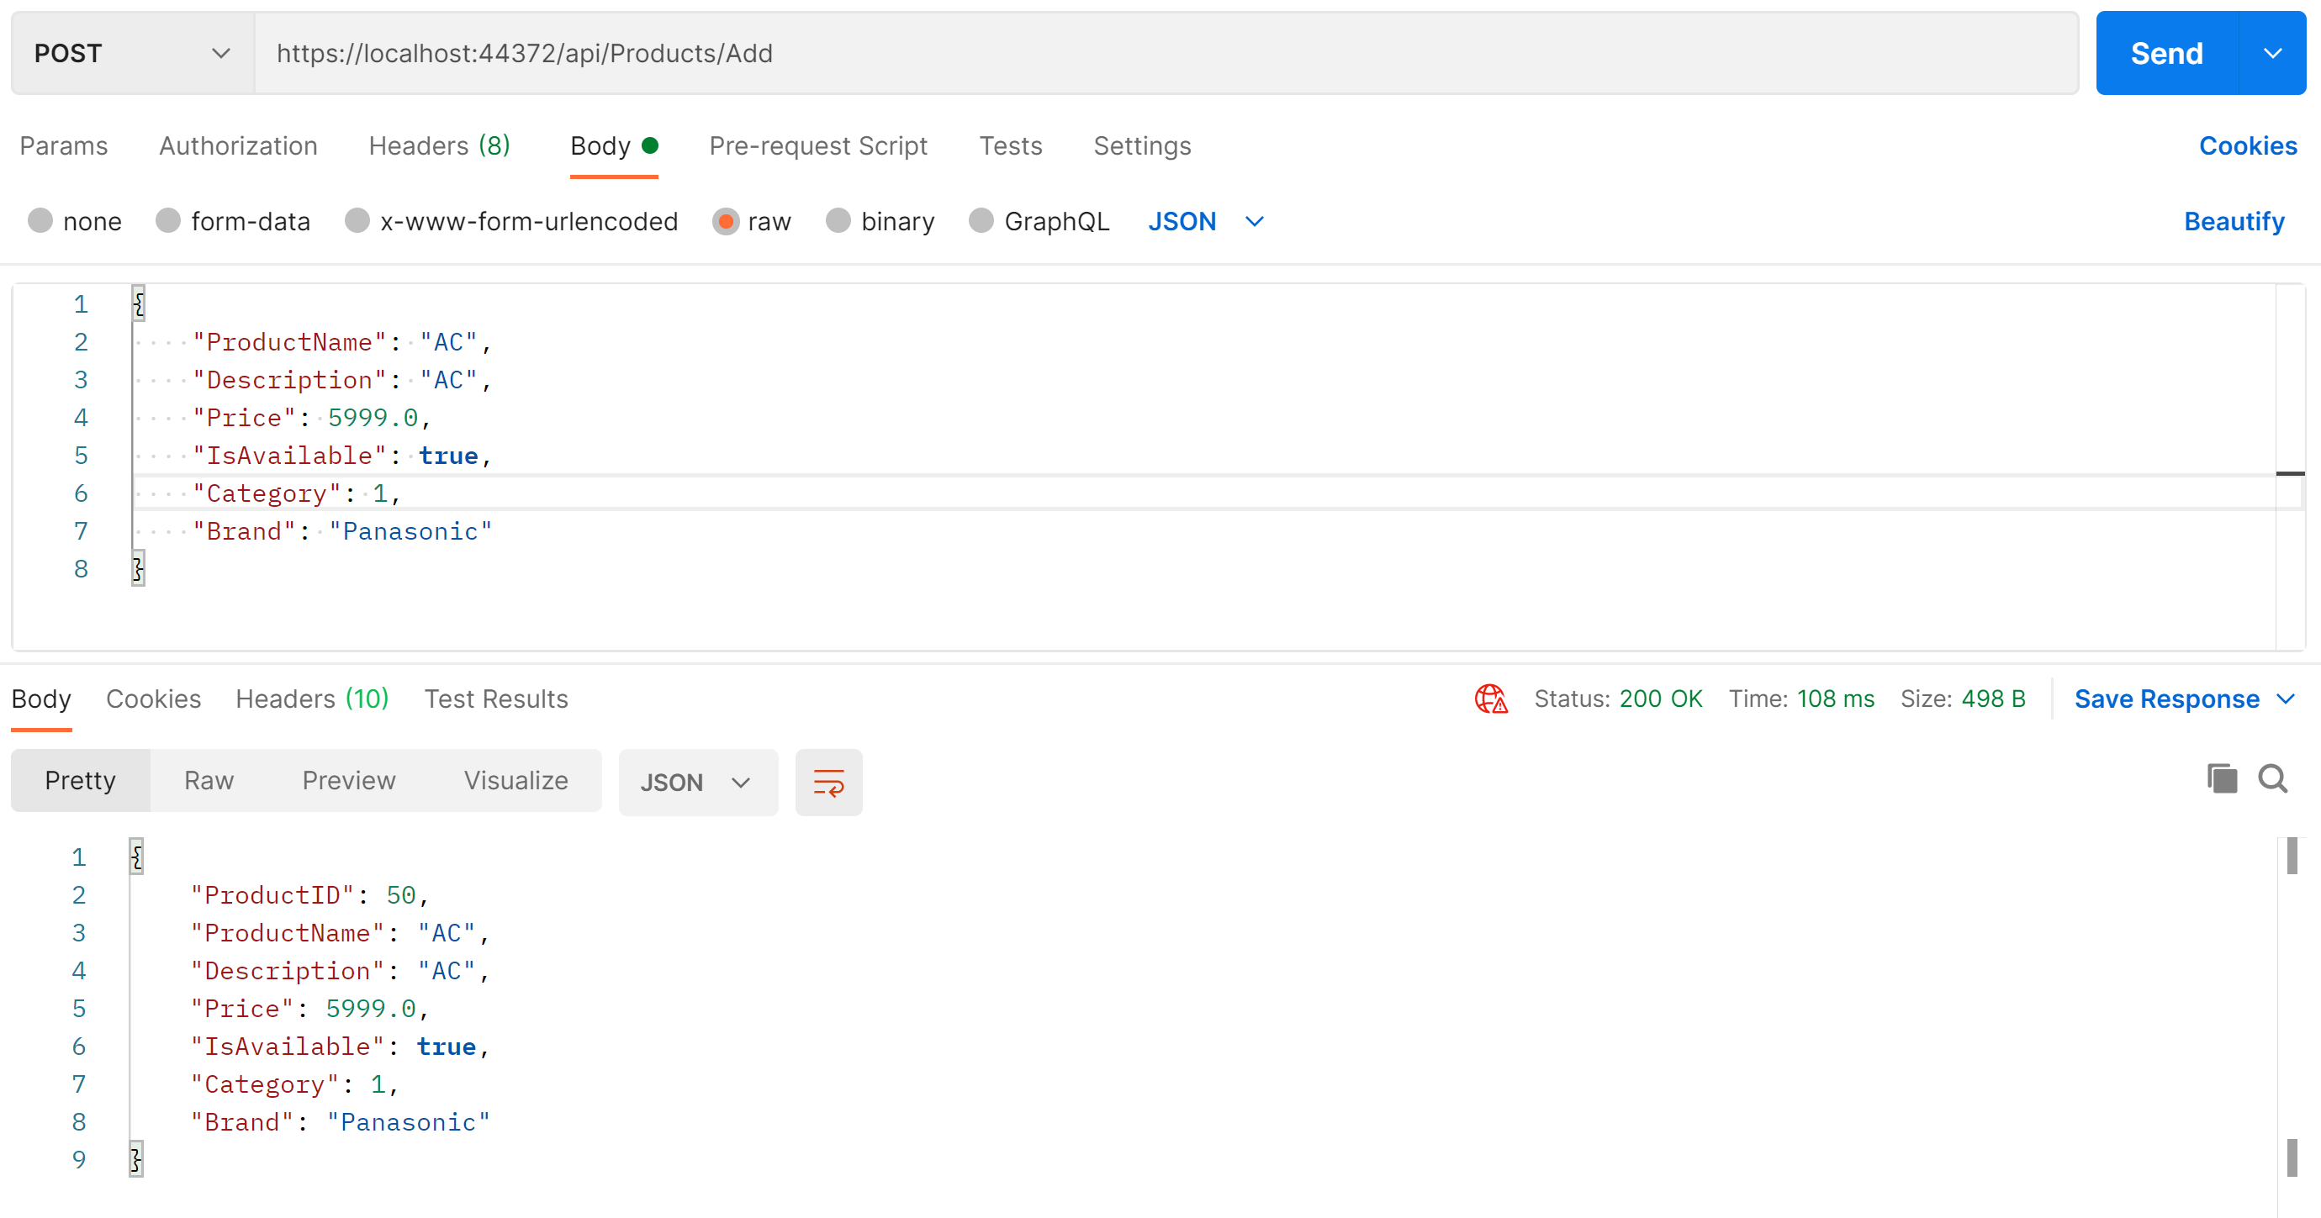

* 1. **api/Products/Modify/{id}**: This is a PUT method to update the details of a product for a particular ProductID

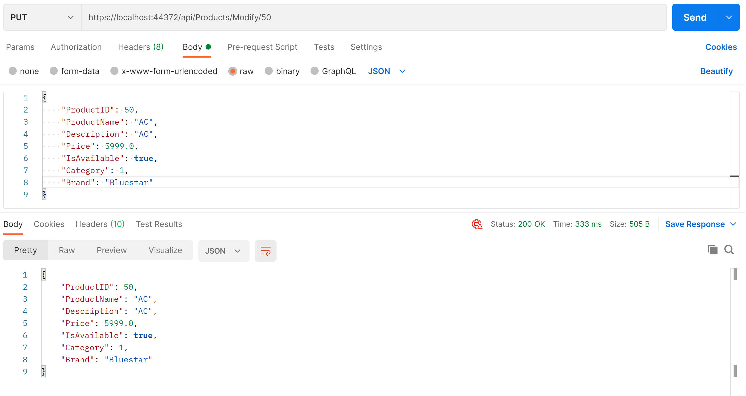

* 1. **api/Products/Delete/{id}**: This is a DELETE method to delete the product from the inventory based on ProductID

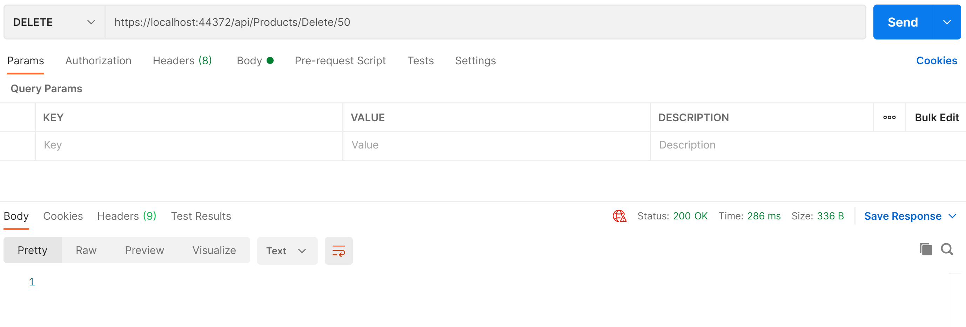

1. Unit Testing Code coverage: Able to achieve **92.41%** code coverage.

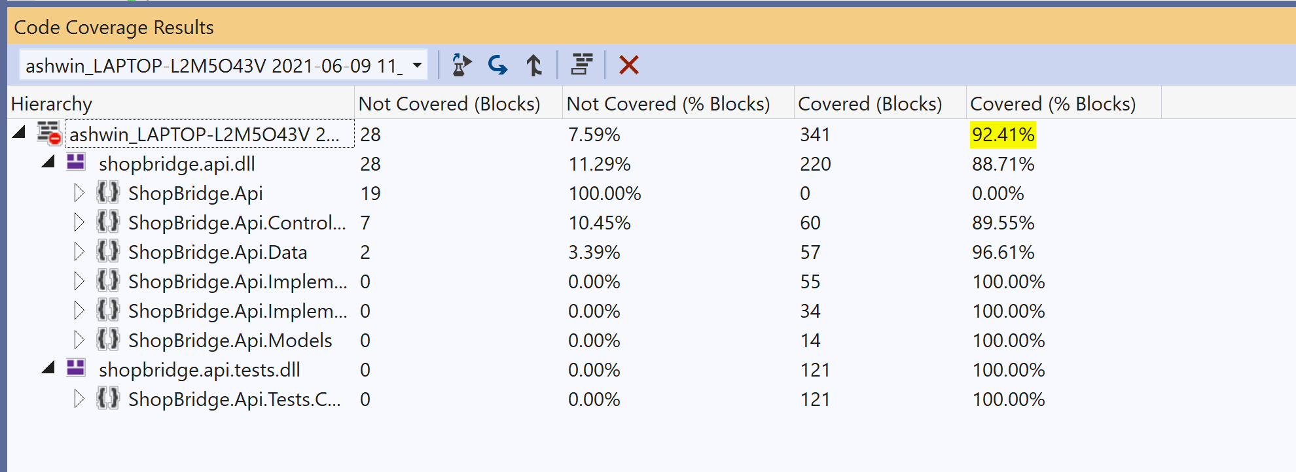

1. Time taken to complete the assessment: 165 mins.

|  |  |
| --- | --- |
| **Task** | **Time (in minutes)** |
| Creating tables | 5 |
| Adding edmx and logic to Get/Insert/Delete records | 20 |
| Implementation Layer to hold all the logic | 30 |
| Creating methods in Product controller | 20 |
| Creating unit test cases | 30 |
| Code clean for better code coverage | 20 |
| Testing all the methods in Postman | 10 |
| Creating the documentation | 20 |
| Uploading the code and required files to GIT | 10 |